UNITED STATES
SECURITIES AND EXCHANGE COMMISSION
Washington, D.C. 20549
Form 6-K
REPORT OF FOREIGN PRIVATE ISSUER PURSUANT TO RULE 13a-16 OR 15d-16 UNDER THE SECURITIES EXCHANGE ACT OF 1934
For the month of May 2026
Commission File Number: 001-35165
BRAINSWAY LTD.
(Translation of registrant's name into English)
16 Hartum Street RAD Tower, 14th Floor
Har HaHotzvim
Jerusalem, 9777516, Israel
(+972-2) 582-4030
(Address and telephone number of Registrant’s principal executive office)
Indicate by check mark whether the registrant files or will file annual reports under cover of Form 20-F or Form 40-F.
Form 20-F [ X ] Form 40-F [ ]
This Form 6-K is incorporated by reference into the Company's Registration Statements on Form S-8 filed with the Securities and Exchange Commission on April 22, 2019 (Registration No. 333-230979) and on April 20, 2026 (Registration No. 333-295189) and the Company's Registration Statements on Form F-3 filed with the Securities and Exchange Commission on July 22, 2024 (Registration No. 333-280934) and on April 22, 2025 (Registration No. 333-286672).

EXHIBIT INDEX
Exhibit | Title
99.1 | Investor Deck

SIGNATURES
Pursuant to the requirements of the Securities Exchange Act of 1934, the registrant has duly caused this report to be signed on its behalf by the undersigned, thereunto duly authorized.
 |  | BRAINSWAY LTD.
 |  | (Registrant)
Date: May 13, 2026 |  | /s/ Hadar Levy
 |  | Hadar Levy
 |  | Chief Executive Officer

Exhibit 99.1

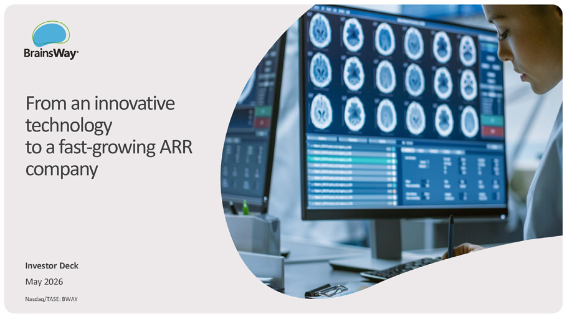
From an innovative technology to a fast - growing ARR company Investor Deck May 2026 Nasdaq/TASE: BWAY Investor Deck | May 2026

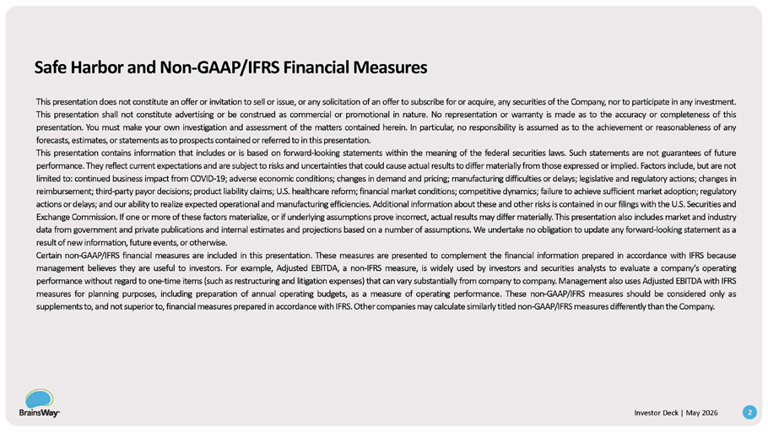
Safe Harbor and Non - GAAP/IFRS Financial Measures 2 Investor Deck | May 2026 This presentation does not constitute a n offer o r invitation to sell o r issue, o r any solicitation of a n offer to subscribe for o r acquire, any securities of th e Company, nor to participate i n any investment . This presentation shall not constitute advertising o r b e construed as commercial o r promotional i n nature . No representation o r warranty is made as to the accuracy o r completeness o f this presentation . You must make your own investigation and assessment of the matters contained herein . I n particular, n o responsibility is assumed as to th e achievement o r reasonableness of any forecasts, estimates, o r statements as to prospects contained o r referred to i n this presentation . This presentation contains information that includes or is based on forward - looking statements within the meaning of the federal securities laws . Such statements are not guarantees of future performance . They reflect current expectations and ar e subject to risks and uncertainties that could cause actual results to differ materially from those expressed o r implied . Factors include, bu t ar e not limited to : continued business impact from COVID - 19 ; adverse economic conditions ; changes i n demand and pricing ; manufacturing difficulties o r delays ; legislative and regulatory actions ; changes in reimbursement ; third - party payor decisions ; product liability claims ; U . S . healthcare reform ; financial market conditions ; competitive dynamics ; failure to achieve sufficient market adoption ; regulatory actions o r delays ; and our ability to realize expected operational and manufacturing efficiencies . Additional information about these and other risks is contained i n our filings with the U . S . Securities and Exchange Commission . If one o r more o f these factors materialize, o r i f underlying assumptions prove incorrect, actual results may differ materially . This presentation also includes market and industry data from government and private publications and internal estimates and projections based o n a number of assumptions . W e undertake n o obligation to update any forward - looking statement as a result of new information, futureevents, o r otherwise . Certain non - GAAP/IFRS financial measures are included in this presentation . These measures are presented to complement the financial information prepared in accordance with IFRS because management believes they are useful to investors . For example, Adjusted EBITDA, a non - IFRS measure, is widely used by investors and securities analysts to evaluate a company’s operating performance without regard to one - time items (such as restructuring and litigation expenses) that can vary substantially from company to company . Management also uses Adjusted EBITDA with IFRS measures for planning purposes, including preparation of annual operating budgets, as a measure of operating performance . These non - GAAP/IFRS measures should be considered only as supplementsto, andnot superiorto, financial measures prepared in accordancewith IFRS . Othercompanies may calculate similarly titled non - GAAP/IFRS measures differently than the Company .

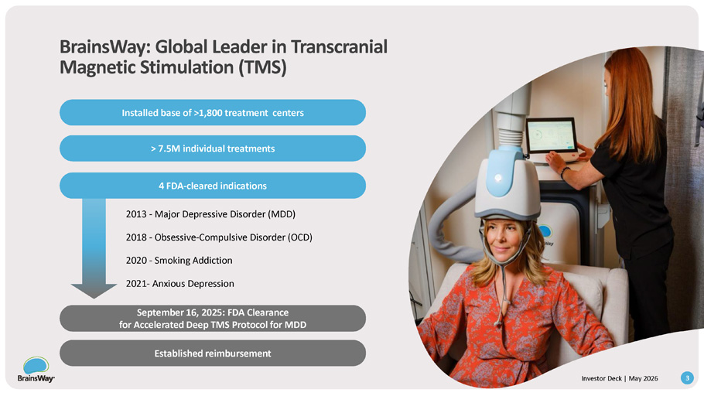
BrainsWay: Global Leader in Transcranial Magnetic Stimulation (TMS) September 16, 2025: FDA Clearance for Accelerated Deep TMS Protocol for MDD Established reimbursement 2013 - Major Depressive Disorder (MDD) 2018 - Obsessive - Compulsive Disorder (OCD) 2020 - Smoking Addiction 2021 - Anxious Depression Installed base of >1,800 treatment centers > 7.5M individual treatments 4 FDA - cleared indications 3 Investor Deck | May 2026

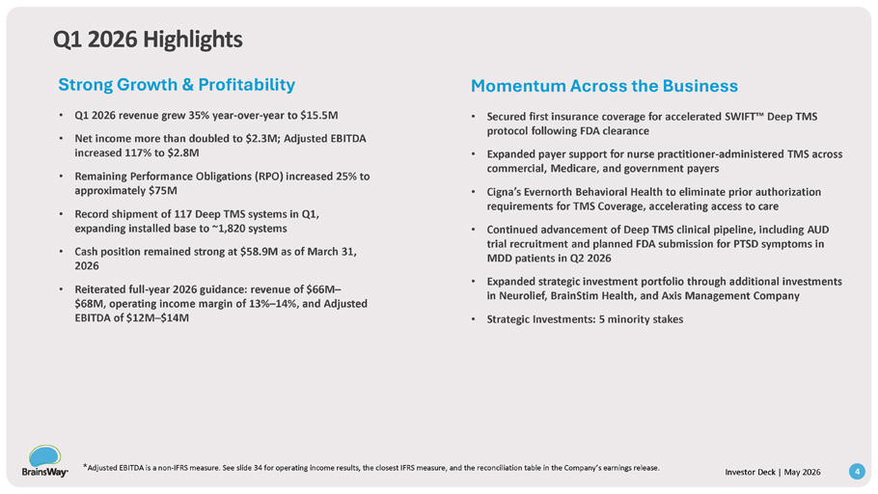
Q1 2026 Highlights Strong Growth & Profitability • Q1 2026 revenue grew 35% year - over - year to $15.5M • Net income more than doubled to $2.3M; Adjusted EBITDA increased 117% to $2.8M • Remaining Performance Obligations (RPO) increased 25% to approximately $75M • Record shipment of 117 Deep TMS systems in Q1, expanding installed base to ~1,820 systems • Cash position remained strong at $58.9M as of March 31, 2026 • Reiterated full - year 2026 guidance: revenue of $66M – $68M, operating income margin of 13% – 14%, and Adjusted EBITDA of $12M – $14M Momentum Across the Business Deep TMS * Adjusted EBITDA is a non - IFRS measure. See slide 34 for operating income results, the closest IFRS measure, and the reconciliation table in the Company’s earnings release. 4 Investor Deck | May 2026 • Secured first insurance coverage for accelerated SWIFT protocol following FDA clearance • Expanded payer support for nurse practitioner - administered TMS across commercial, Medicare, and government payers • Cigna’s Evernorth Behavioral Health to eliminate prior authorization requirements for TMS Coverage, accelerating access to care • Continued advancement of Deep TMS clinical pipeline, including AUD trial recruitment and planned FDA submission for PTSD symptoms in MDD patients in Q2 2026 • Expanded strategic investment portfolio through additional investments in Neurolief, BrainStim Health, and Axis Management Company • Strategic Investments: 5 minority stakes

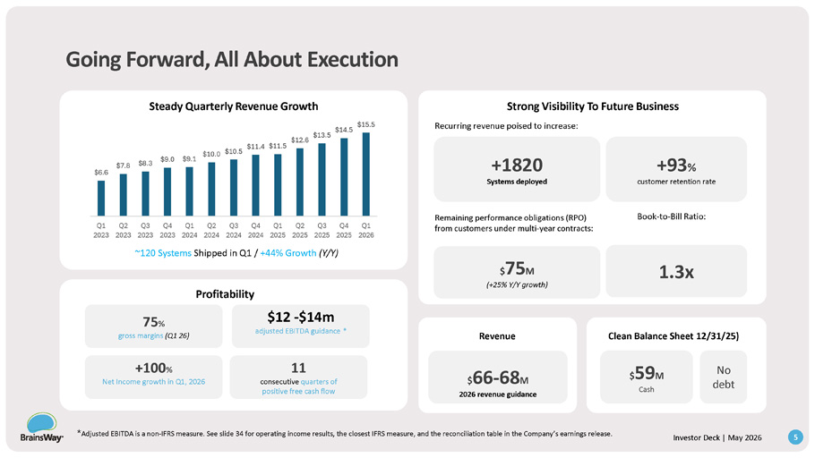
Going Forward, All About Execution Steady Quarterly Revenue Growth ~120 Systems Shipped in Q1 / +44% Growth (Y/Y) Profitability Revenue Clean Balance Sheet 12/31/25) 75 % gross margins (Q1 26) +100 % Net Income growth in Q1, 2026 11 consecutive quarters of positive free cash flow +1820 Systems deployed +93 % customer retention rate Strong Visibility To Future Business Recurring revenue poised to increase: Remaining performance obligations (RPO) from customers under multi - year contracts: $ 75 M (+25% Y/Y growth) $ 66 - 68 M 2026 revenue guidance Book - to - Bill Ratio: 1.3x $ 59 M Cash No debt $6.6 * Adjusted EBITDA is a non - IFRS measure. See slide 34 for operating income results, the closest IFRS measure, and the reconciliation table in the Company’s earnings release. 5 Investor Deck | May 2026 $7.8 $8.3 $9.0 $9.1 $12.6 $13.5 $10.0 $10.5 $11.4 $11.5 $14.5 $15.5 Q1 Q2 Q3 Q4 2023 2023 2023 2023 Q1 Q2 Q3 Q4 Q1 2024 2024 2024 2024 2025 Q2 Q3 2025 2025 Q4 Q1 2025 2026 $12 - $14m adjusted EBITDA guidance *

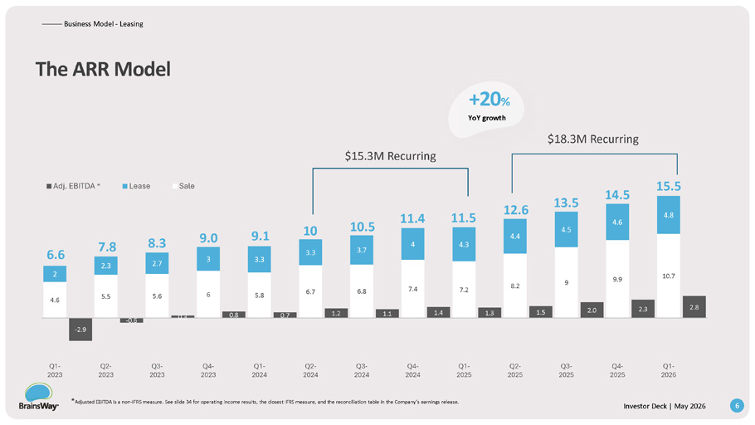
4.6 5.5 5.6 6 5.8 6.7 6.8 7.4 7.2 8.2 9 9.9 10.7 2 2.3 2.7 3 3.3 3.3 3.7 4 4.3 4.4 4.5 4.6 4.8 - 2.9 - 0.6 0.3 0.8 0.7 1.2 1.1 1.4 1.3 1.5 2.0 2.3 2.8 Q1 - Q4 - Q3 - Q2 - Q1 - Q4 - Q3 - Q2 - Q1 - Q4 - Q3 - Q2 - Q1 - 2026 2025 2025 2025 2025 2024 2024 2024 2024 2023 2023 2023 2023 Adj. EBITDA * Lease Sale The ARR Model * Adjusted EBITDA is a non - IFRS measure. See slide 34 for operating income results, the closest IFRS measure, and the reconciliation table in the Company’s earnings release. 6 Investor Deck | May 2026 ——— — Business Model - Leasing 12.6 11.4 10.5 10 9.1 9.0 8.3 7.8 6.6 11.5 13.5 +20 % YoY growth $18.3M Recurring $15.3M Recurring 14.5 15.5

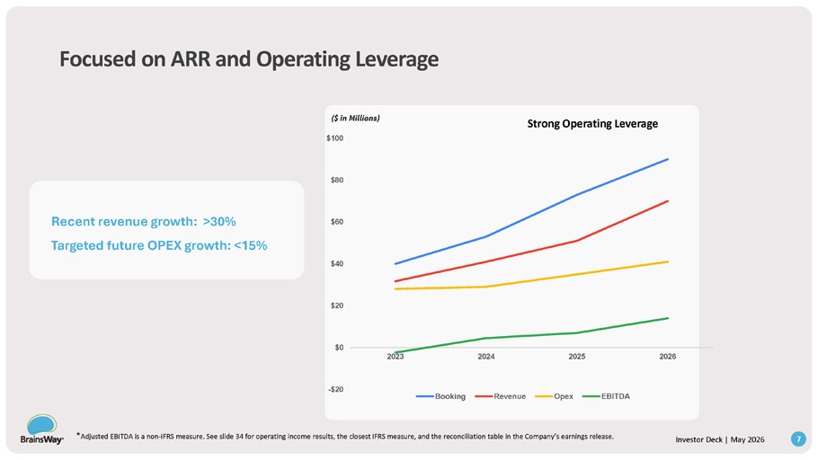
Focused on ARR and Operating Leverage Recent revenue growth: >30% Targeted future OPEX growth: <15% Strong Operating Leverage ($ in Millions) - $20 $0 $20 $40 $60 $80 $100 2023 2024 2025 2026 Booking Revenue Opex EBITDA * Adjusted EBITDA is a non - IFRS measure. See slide 34 for operating income results, the closest IFRS measure, and the reconciliation table in the Company’s earnings release. 7 Investor Deck | May 2026

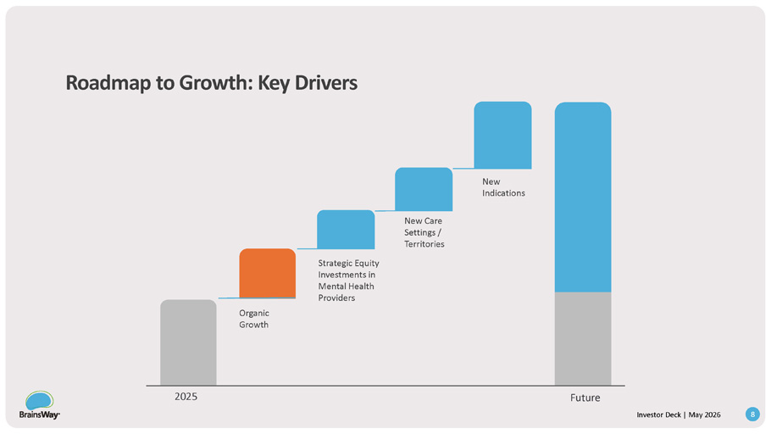
Roadmap to Growth: Key Drivers New Indications New Care Settings / Territories Strategic Equity Investments in Mental Health Providers Organic Growth 2025 Future 8 Investor Deck | May 2026

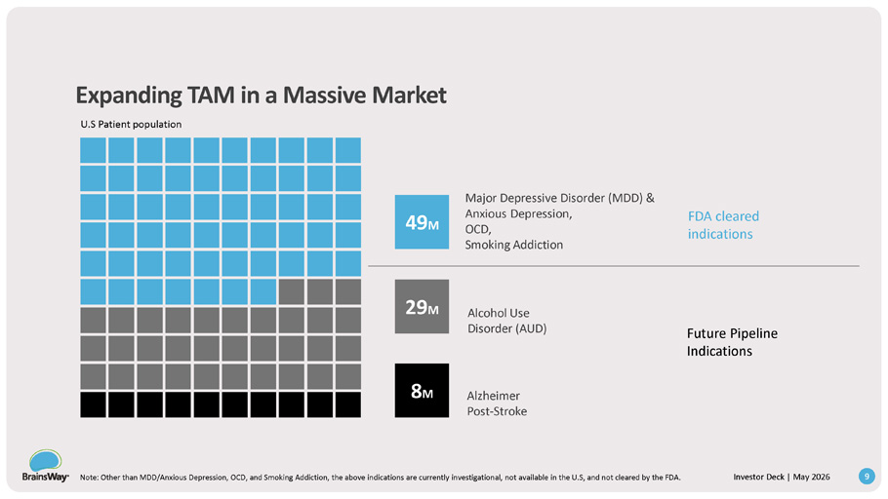
Expanding TAM in a Massive Market Major Depressive Disorder (MDD) & Anxious Depression, OCD, Smoking Addiction Alcohol Use Disorder (AUD) Alzheimer Post - Stroke Future Pipeline Indications U.S Patient population FDA cleared indications 49 M 29 M 8 M 9 Investor Deck | May 2026 Note: Other than MDD/Anxious Depression, OCD, and Smoking Addiction, the above indications are currently investigational, not available in the U.S, and not cleared by the FDA.

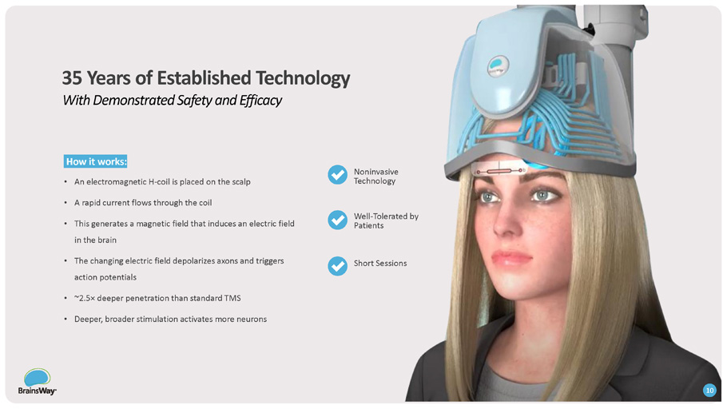
Investor Deck | May 2026 How it works: • An electromagnetic H - coil is placed on the scalp • A rapid current flows through the coil • This generates a magnetic field that induces an electric field in the brain • The changing electric field depolarizes axons and triggers action potentials • ~2.5 п deeper penetration than standard TMS • Deeper, broader stimulation activates more neurons Noninvasive Technology Well - Tolerated by Patients Short Sessions 35 Years of Established Technology With Demonstrated Safety and Efficacy 10

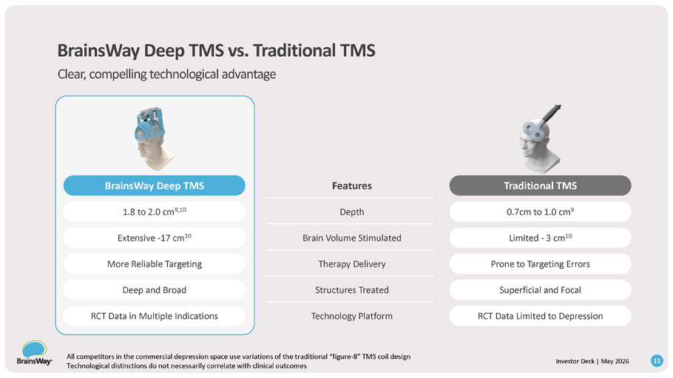
Investor Deck | May 2026 All competitors in the commercial depression space use variations of the traditional “figure - 8” TMS coil design Technological distinctions do not necessarily correlate with clinical outcomes BrainsWay Deep TMS Traditional TMS 1.8 to 2.0 cm 9,10 Extensive - 17 cm 10 More Reliable Targeting Deep and Broad RCT Data in Multiple Indications 0.7cm to 1.0 cm 9 Limited - 3 cm 10 Prone to Targeting Errors Superficial and Focal RCT Data Limited to Depression Features Depth Brain Volume Stimulated Therapy Delivery Structures Treated Technology Platform BrainsWay Deep TMS vs. Traditional TMS Clear, compelling technological advantage 11

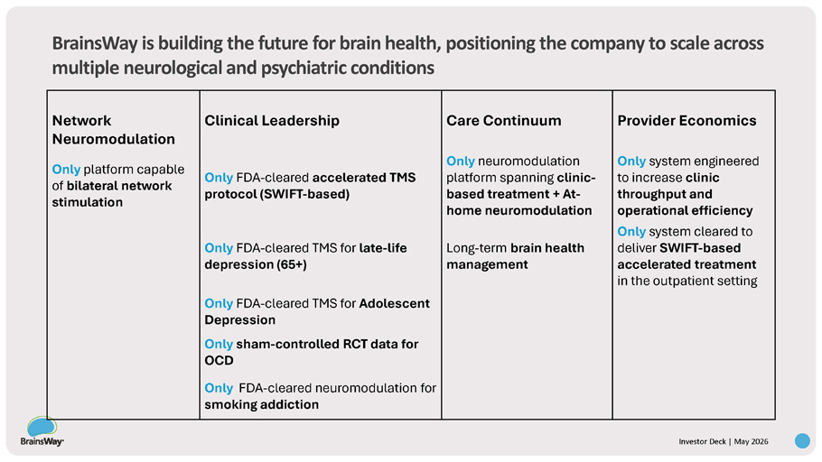
Provider Economics Care Continuum Clinical Leadership Network Neuromodulation Only system engineered to increase clinic throughput and operational efficiency Only neuromodulation platform spanning clinic - based treatment + At - home neuromodulation Only FDA - cleared accelerated TMS protocol (SWIFT - based) Only platform capable of bilateral network stimulation Only system cleared to deliver SWIFT - based accelerated treatment in the outpatient setting Long - term brain health management Only FDA - cleared TMS for late - life depression (65+) Only FDA - cleared TMS for Adolescent Depression Only sham - controlled RCT data for OCD Only FDA - cleared neuromodulation for smoking addiction Investor Deck | May 2026 BrainsWay is building the future for brain health, positioning the company to scale across multiple neurological and psychiatric conditions

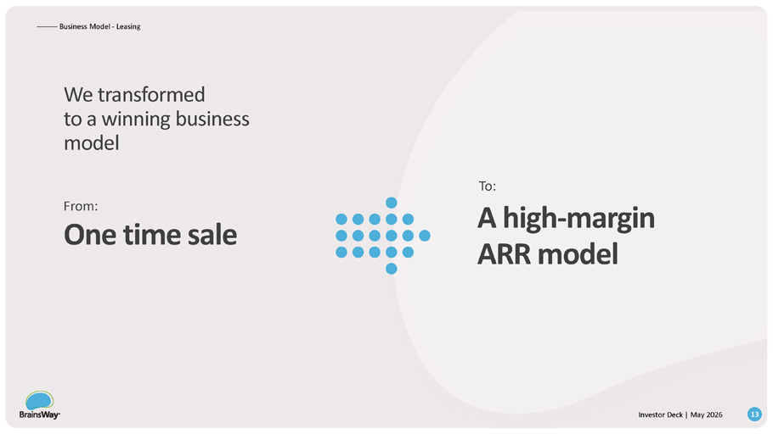
We transformed to a winning business model ——— — Business Model - Leasing From: One time sale To: A high - margin ARR model 13 Investor Deck | May 2026

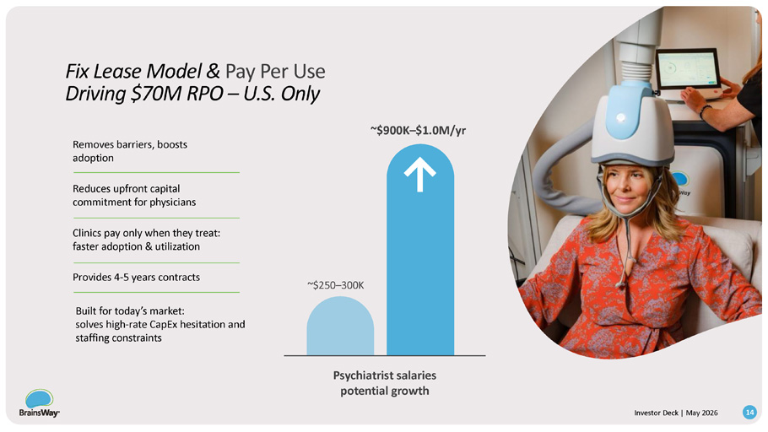
Provides 4 - 5 years contracts Built for today’s market: solves high - rate CapEx hesitation and staffing constraints Removes barriers, boosts adoption Reduces upfront capital commitment for physicians Clinics pay only when they treat: faster adoption & utilization ~$250 – 300K ~$900K – $1.0M/yr Psychiatrist salaries potential growth Fix Lease Model & Pay Per Use Driving $70M RPO – U.S. Only 14 Investor Deck | May 2026

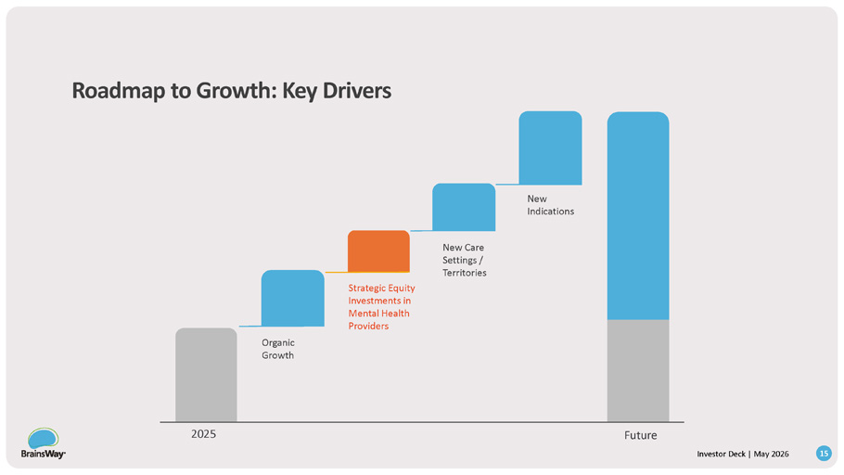
Roadmap to Growth: Key Drivers New Indications New Care Settings / Territories Strategic Equity Investments in Mental Health Providers Organic Growth 2025 Future 15 Investor Deck | May 2026

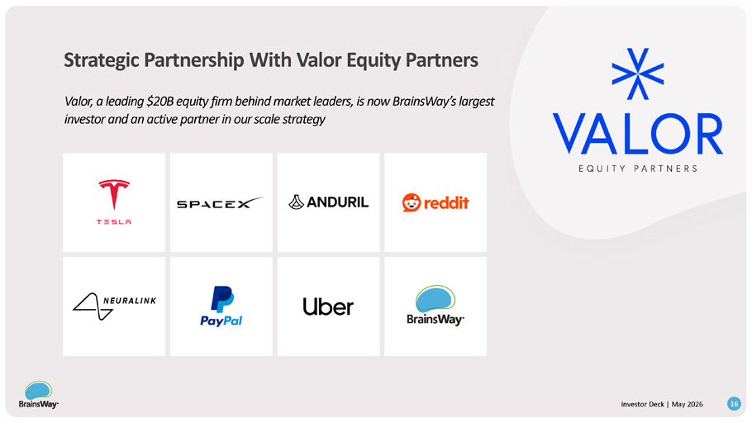
Strategic Partnership With Valor Equity Partners 16 Investor Deck | May 2026 Valor, a leading $20B equity firm behind market leaders, is now BrainsWay’s largest investor and an active partner in our scale strategy

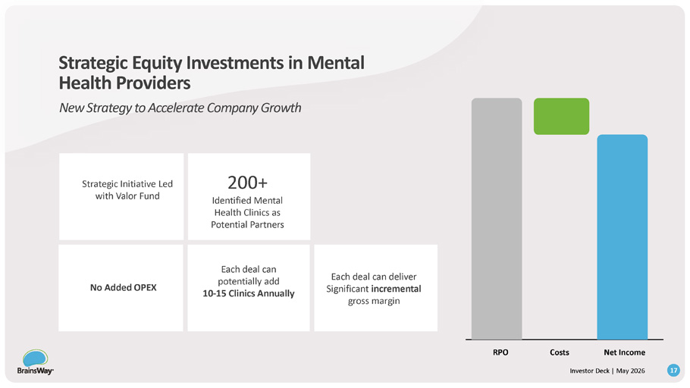
RPO Costs Net Income 200+ Identified Mental Strategic Initiative Led with Valor Fund Health Clinics as Potential Partners Each deal can deliver Significant incremental gross margin Each deal can potentially add 10 - 15 Clinics Annually No Added OPEX Strategic Equity Investments in Mental Health Providers New Strategy to Accelerate Company Growth 17 Investor Deck | May 2026

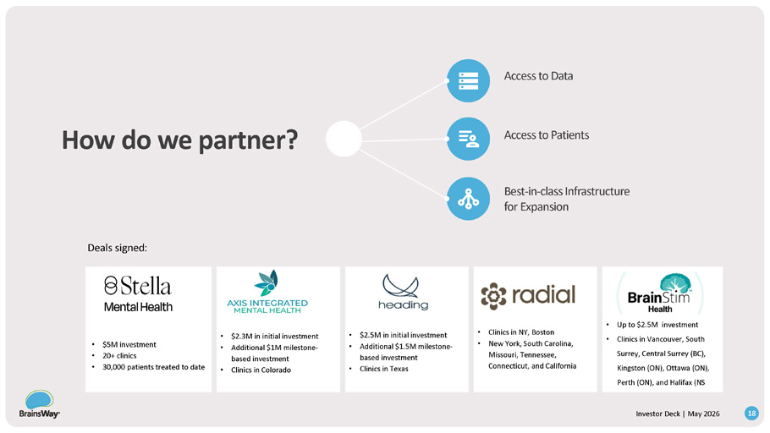
• $5M investment • 20+ clinics • 30,000 patients treated to date • $2.3M in initial investment • Additional $1M milestone - based investment • Clinics in Colorado • $2.5M in initial investment • Additional $1.5M milestone - based investment • Clinics in Texas • Clinics in NY, Boston • New York, South Carolina, Missouri, Tennessee, Connecticut, and California • Up to $ 2 . 5 M investment • Clinics in Vancouver, South Surrey, Central Surrey (BC), Kingston (ON), Ottawa (ON), Perth (ON), and Halifax (NS How do we partner? Deals signed : 18 Investor Deck | May 2026 Access to Data Access to Patients Best - in - class Infrastructure for Expansion

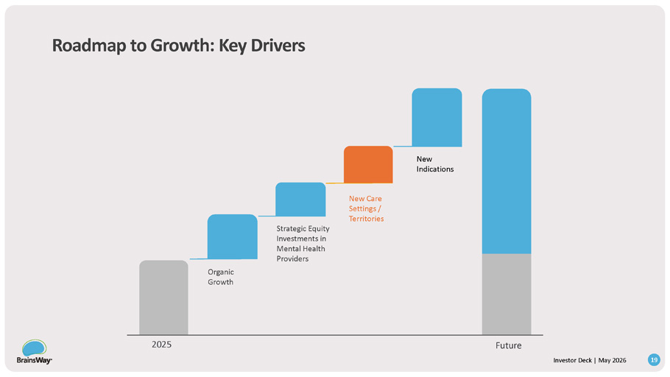
Roadmap to Growth: Key Drivers New Indications New Care Settings / Territories Strategic Equity Investments in Mental Health Providers Organic Growth 2025 Future 19 Investor Deck | May 2026

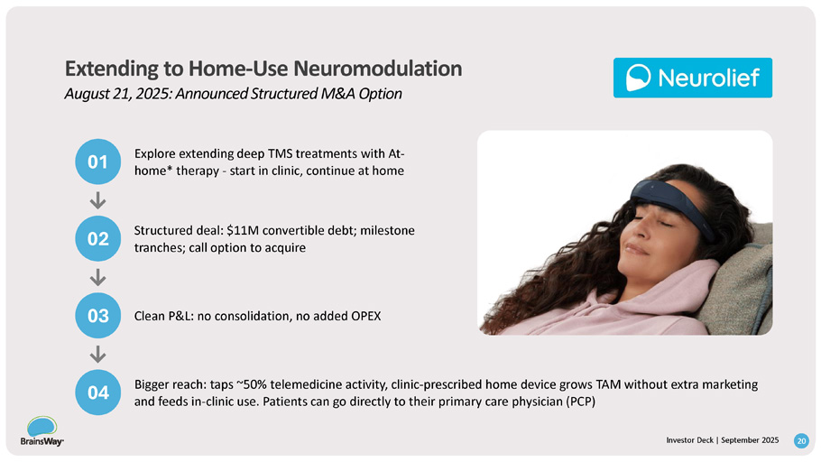
03 02 01 Explore extending deep TMS treatments with At - home* therapy - start in clinic, continue at home 04 Bigger reach: taps ~50% telemedicine activity, clinic - prescribed home device grows TAM without extra marketing and feeds in - clinic use. Patients can go directly to their primary care physician (PCP) Structured deal: $11M convertible debt; milestone tranches; call option to acquire Clean P&L: no consolidation, no added OPEX Extending to Home - Use Neuromodulation August 21, 2025: Announced Structured M&A Option I n v e I n s t v o e r s t D o e r c D k e | c S k e | p M t e a m y b 2 e 0 r 2 2 6 025 20

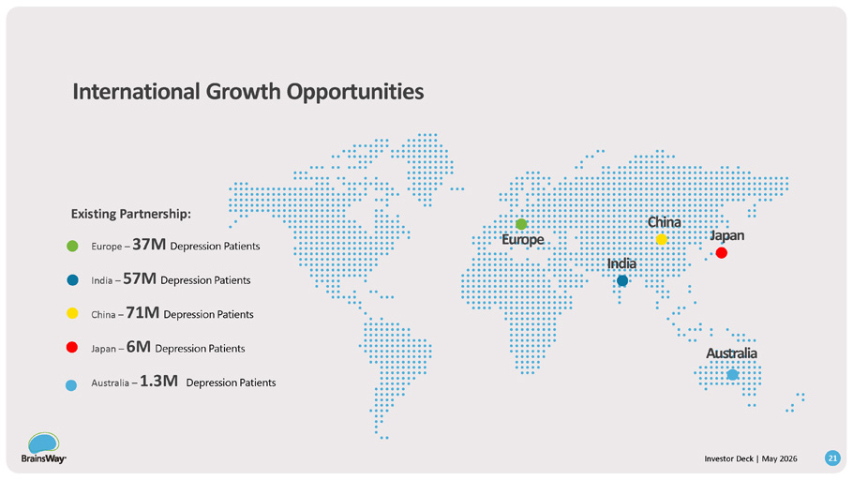
Europe – 37M Depression Patients India – 57M Depression Patients China – 71M Depression Patients Japan – 6M Depression Patients Australia – 1.3M Depression Patients Existing Partnership: Europ e India China Australia Japan International Growth Opportunities 21 Investor Deck | May 2026

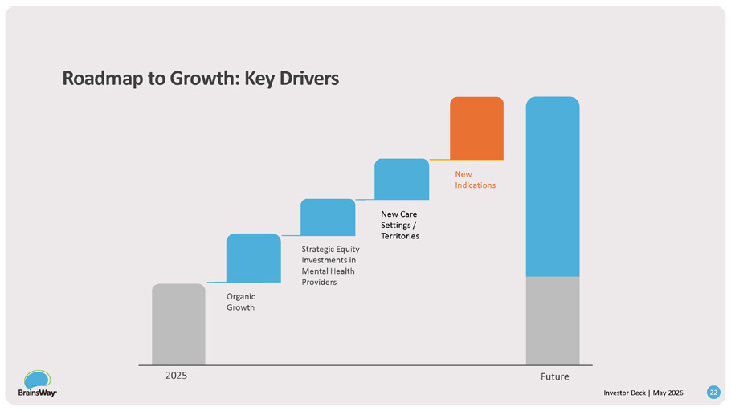
Roadmap to Growth: Key Drivers New Indications New Care Settings / Territories Strategic Equity Investments in Mental Health Providers Organic Growth 2025 Future 22 Investor Deck | May 2026

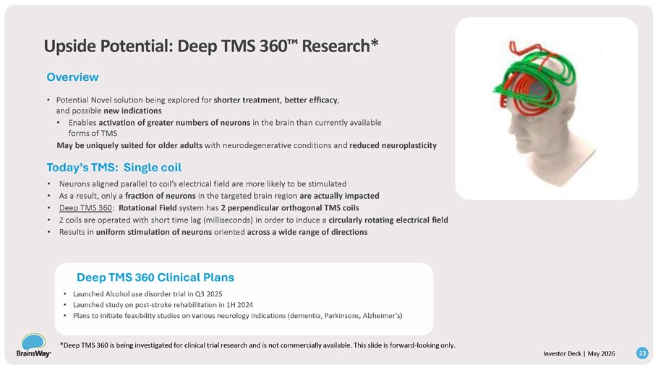
Upside Potential: Deep TMS 360 Research* Overview • Potential Novel solution being explored for shorter treatment , better efficacy , and possible new indications • Enables activation of greater numbers of neurons in the brain than currently available forms of TMS May be uniquely suited for older adults with neurodegenerative conditions and reduced neuroplasticity Today’s TMS: Single coil • Neurons aligned parallel to coil’s electrical field are more likely to be stimulated • As a result, only a fraction of neurons in the targeted brain region are actually impacted • Deep TMS 360 : Rotational Field system has 2 perpendicular orthogonal TMS coils • 2 coils are operated with short time lag (milliseconds) in order to induce a circularly rotating electrical field • Results in uniform stimulation of neurons oriented across a wide range of directions 23 Investor Deck | May 2026 Deep TMS 360 Clinical Plans • Launched Alcohol use disorder trial in Q3 2025 • Launched study on post - stroke rehabilitation in 1H 2024 • Plans to initiate feasibility studies on various neurology indications (dementia, Parkinsons, Alzheimer's) *Deep TMS 360 is being investigated for clinical trial research and is not commercially available. This slide is forward - looking only.

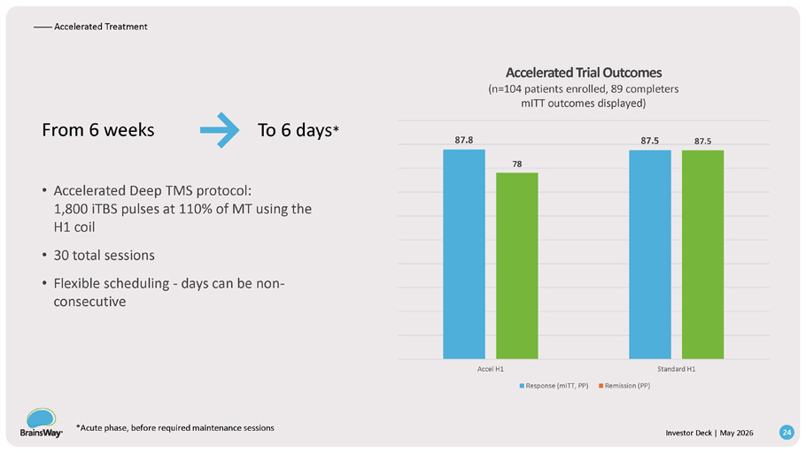
From 6 weeks To 6 days * • Accelerated Deep TMS protocol: 1,800 iTBS pulses at 110% of MT using the H1 coil • 30 total sessions • Flexible scheduling - days can be non - consecutive 78 87.8 87.5 87.5 Accel H1 Standard H1 Accelerated Trial Outcomes (n=104 patients enrolled, 89 completers mITT outcomes displayed) Response (mITT, PP) Remission (PP) —— Accelerated Treatment *Acute phase, before required maintenance sessions 24 Investor Deck | May 2026

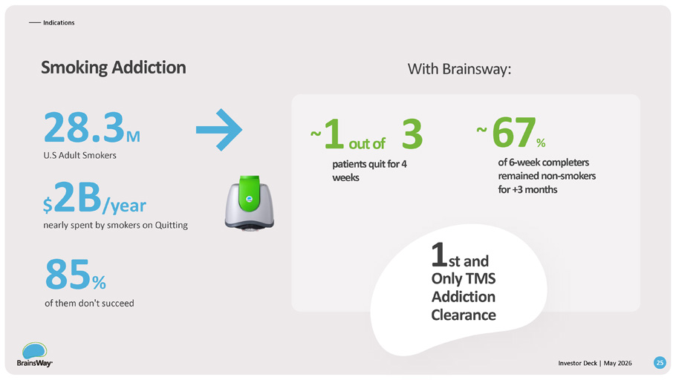
— — Indications Smoking Addiction 28.3 M U.S Adult Smokers $ 2B /year nearly spent by smokers on Quitting 85 % of them don't succeed With Brainsway: ~ 67 % of 6 - week completers remained non - smokers for +3 months ~ 1 o u t of 3 patients quit for 4 weeks 1 st and Only TMS Addiction Clearance 25 Investor Deck | May 2026

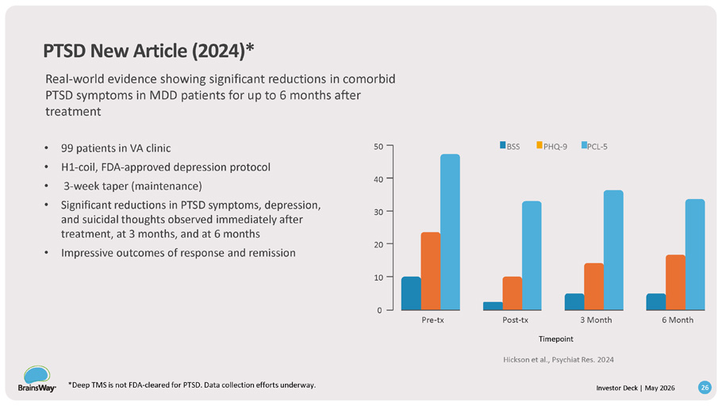
Pre - tx Post - tx 3 Month 6 Month 20 10 0 40 30 50 BSS *Deep TMS is not FDA - cleared for PTSD. Data collection efforts underway. 26 Investor Deck | May 2026 PHQ - 9 PCL - 5 PTSD New Article (2024)* Real - world evidence showing significant reductions in comorbid PTSD symptoms in MDD patients for up to 6 months after treatment • 99 patients in VA clinic • H1 - coil, FDA - approved depression protocol • 3 - week taper (maintenance) • Significant reductions in PTSD symptoms, depression, and suicidal thoughts observed immediately after treatment, at 3 months, and at 6 months • Impressive outcomes of response and remission Timepoint Hickson et al., Psychiat Res. 2024

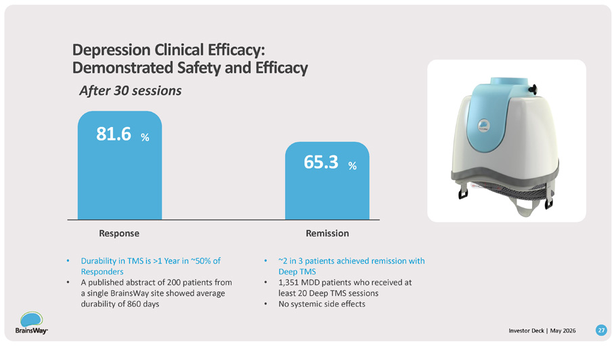
Depression Clinical Efficacy: Demonstrated Safety and Efficacy After 30 sessions 81.6 % Remission 65.3 % Response • Durability in TMS is >1 Year in ~50% of Responders • A published abstract of 200 patients from a single BrainsWay site showed average durability of 860 days • ~2 in 3 patients achieved remission with Deep TMS • 1,351 MDD patients who received at least 20 Deep TMS sessions • No systemic side effects 27 Investor Deck | May 2026

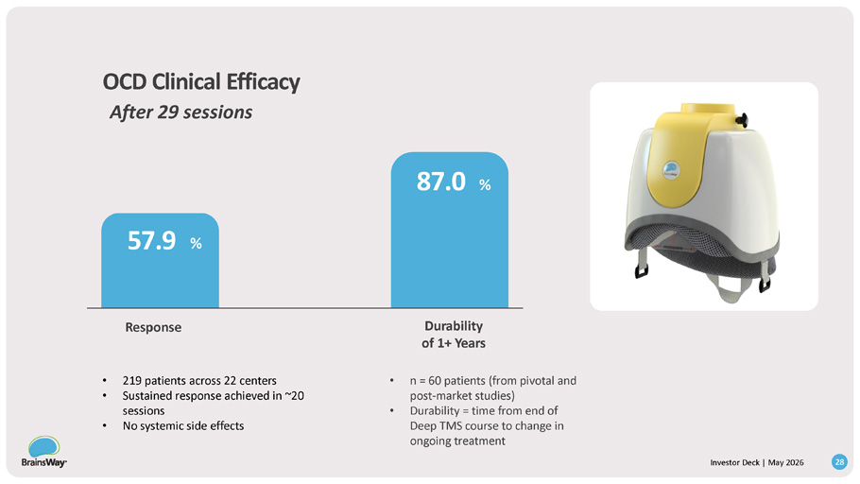
OCD Clinical Efficacy After 29 sessions 57.9 % Durability of 1+ Years 87.0 % Response • 219 patients across 22 centers • Sustained response achieved in ~20 sessions • No systemic side effects • n = 60 patients (from pivotal and post - market studies) • Durability = time from end of Deep TMS course to change in ongoing treatment 28 Investor Deck | May 2026

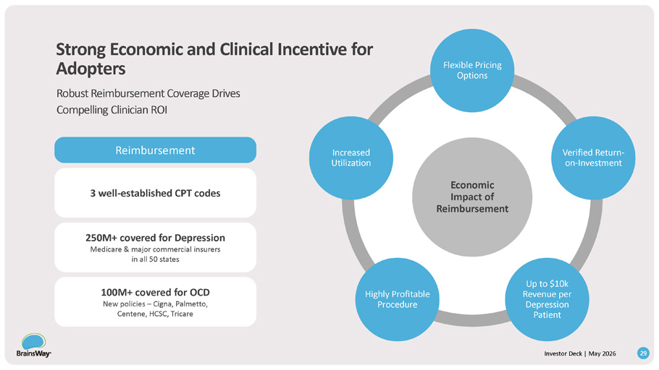
Economic Impact of Reimbursement 29 Investor Deck | May 2026 Flexible Pricing Options Verified Return - on - Investment Up to $10k Revenue per Depression Patient Highly Profitable Procedure Increased Utilization 3 well - established CPT codes Reimbursement 250M+ covered for Depression Medicare & major commercial insurers in all 50 states 100M+ covered for OCD New policies – Cigna, Palmetto, Centene, HCSC, Tricare Strong Economic and Clinical Incentive for Adopters Robust Reimbursement Coverage Drives Compelling Clinician ROI

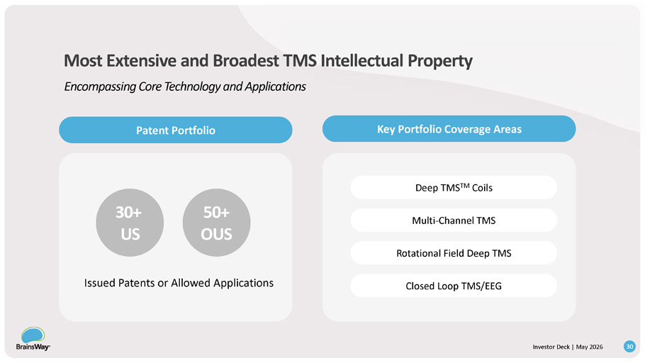
30+ US 50+ OUS Deep TMS TM Coils Multi - Channel TMS Rotational Field Deep TMS Closed Loop TMS/EEG Issued Patents or Allowed Applications Most Extensive and Broadest TMS Intellectual Property Encompassing Core Technology and Applications Key Portfolio Coverage Areas Patent Portfolio 30 Investor Deck | May 2026

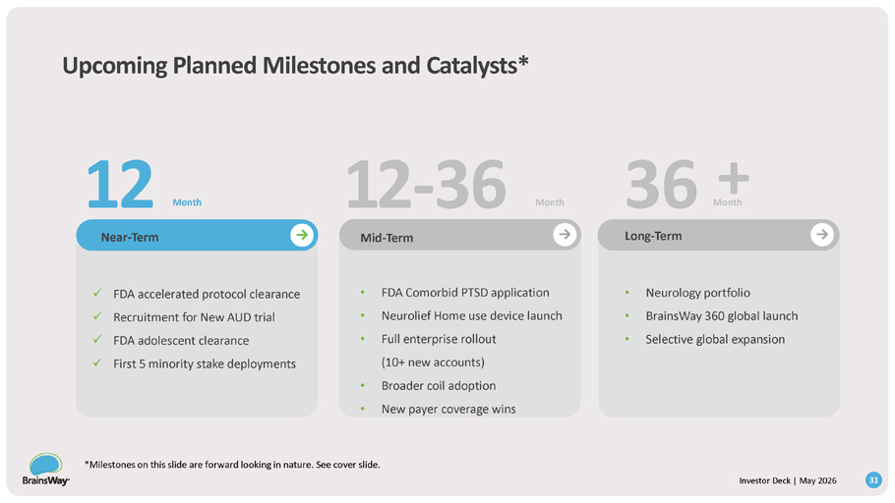
Upcoming Planned Milestones and Catalysts* 31 Investor Deck | May 2026 • FDA Comorbid PTSD application • Neurolief Home use device launch • Full enterprise rollout (10+ new accounts) • Broader coil adoption • New payer coverage wins Long - Term • Neurology portfolio • BrainsWay 360 global launch • Selective global expansion Near - Term Mid - Term x FDA accelerated protocol clearance x Recruitment for New AUD trial x FDA adolescent clearance x First 5 minority stake deployments Month 12 12 - 36 36 Month M + o n th *Milestones on this slide are forward looking in nature. See cover slide.

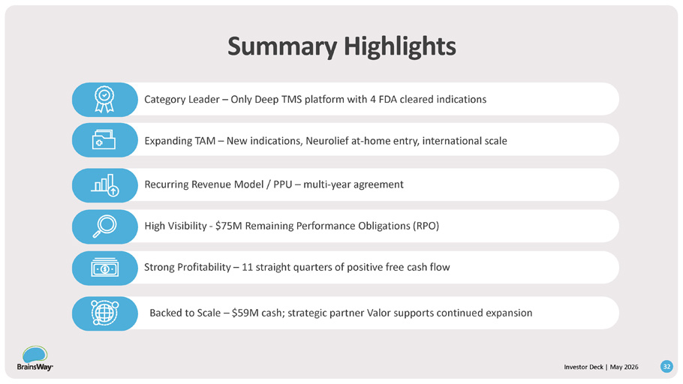
Summary Highlights 32 Investor Deck | May 2026 Category Leader – Only Deep TMS platform with 4 FDA cleared indications Expanding TAM – New indications, Neurolief at - home entry, international scale Recurring Revenue Model / PPU – multi - year agreement High Visibility - $75M Remaining Performance Obligations (RPO) Strong Profitability – 11 straight quarters of positive free cash flow Backed to Scale – $59M cash; strategic partner Valor supports continued expansion

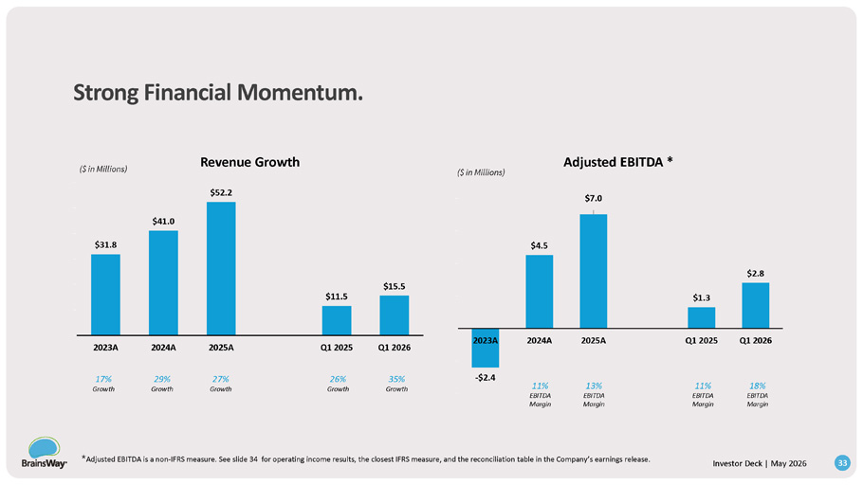
Strong Financial Momentum. $31.8 $41.0 $52.2 $11.5 $15.5 $0. 00 $10 .00 $20 .00 $30 .00 $40 .00 $50 .00 $60 .00 2023A 2024A 2025A Q1 2025 Q1 2026 Revenue Growth - $2.4 * Adjusted EBITDA is a non - IFRS measure. See slide 34 for operating income results, the closest IFRS measure, and the reconciliation table in the Company’s earnings release. 33 Investor Deck | May 2026 $4.5 $7.0 $1.3 $2.8 - $4.00 - $2.00 $0. 00 $2. 00 $4. 00 $6. 00 $8. 00 2023A 2024A 2025A Q1 2025 Q1 2026 Adjusted EBITDA * ($ in Millions) ($ in Millions) 35% Growth 26% Growth 27% Growth 29% Growth 17% Growth 18% EBITDA Margin 11% EBITDA Margin 13% EBITDA Margin 11% EBITDA Margin

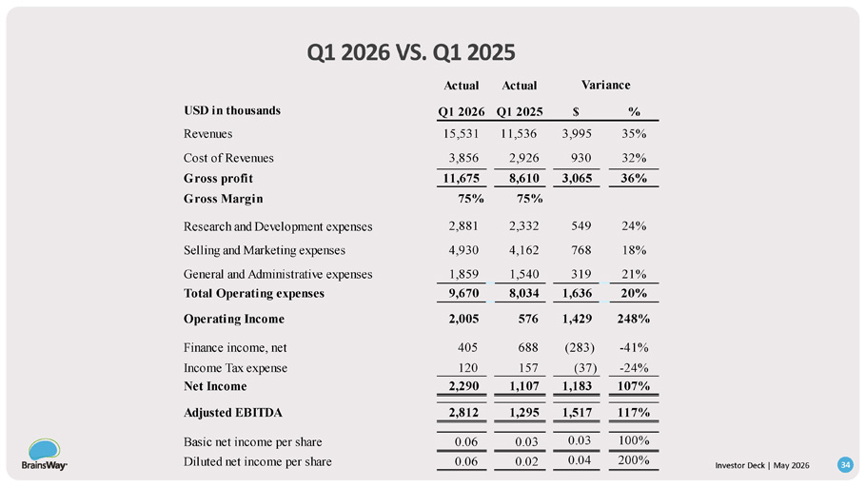
Q1 2026 VS. Q1 2025 Variance Actual Actual % $ Q1 2025 Q1 2026 USD in thousands 35% 3,995 11,536 15,531 Revenues 32% 930 2,926 3,856 Cost of Revenues 36% 3,065 8,610 11,675 Gross profit 75% 75% Gross Margin 24% 549 2,332 2,881 Research and Development expenses 18% 768 4,162 4,930 Selling and Marketing expenses 21% 319 1,540 1,859 General and Administrative expenses 20% 1,636 8,034 9,670 Total Operating expenses 248% 1,429 576 2,005 Operating Income - 41% (283) 688 405 Finance income, net - 24% (37) 157 120 Income Tax expense 107% 1,183 1,107 2,290 Net Income 117% 1,517 1,295 2,812 Adjusted EBITDA 100% 0.03 0.03 0.06 Basic net income per share 0.04 200% Diluted net income per share 0.06 0.02 34 Investor Deck | May 2026

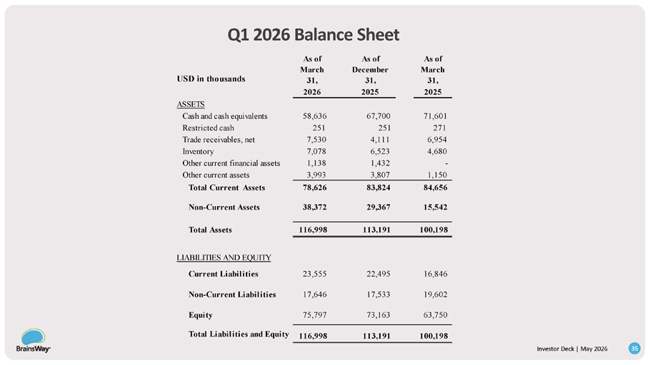
Q1 2026 Balance Sheet Investor Deck | May 2026 35 As of March As of December As of March 31, 31, 31, USD in thousands 2025 2025 2026 ASSETS 71,601 67,700 58,636 Cash and cash equivalents 271 251 251 Restricted cash 6,954 4,111 7,530 Trade receivables, net 4,680 6,523 7,078 Inventory - 1,432 1,138 Other current financial assets 1,150 3,807 3,993 Other current assets 84,656 83,824 78,626 Total Current Assets 15,542 29,367 38,372 Non - Current Assets 100,198 113,191 116,998 Total Assets LIABILITIES AND EQUITY 16,846 22,495 23,555 Current Liabilities 19,602 17,533 17,646 Non - Current Liabilities 63,750 73,163 75,797 Equity 100,198 113,191 116,998 Total Liabilities and Equity

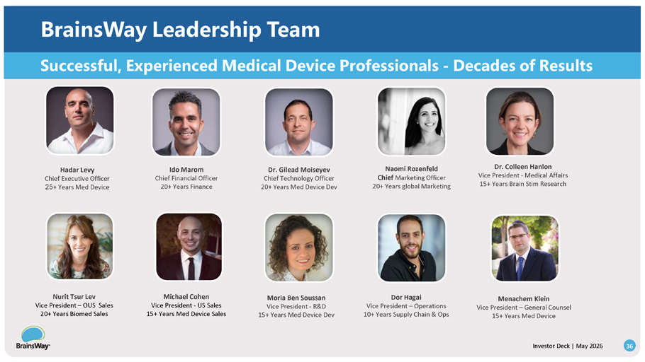
Moria Ben Soussan Vice President - R&D 15+ Years Med Device Dev Hadar Levy Chief Executive Officer 25 + Years Med Device Michael Cohen Vice President - US Sales 15+ Years Med Device Sales Dr. Colleen Hanlon Vice President - Medical Affairs 15+ Years Brain Stim Research Dr. Gilead Moiseyev Chief Technology Officer 20+ Years Med Device Dev Dor Hagai Vice President – Operations 10+ Years Supply Chain & Ops Ido Marom Chief Financial Officer 20+ Years Finance Nurit Tsur Lev Vice President – OUS Sales 20+ Years Biomed Sales Naomi Rozenfeld Chief Marketing Officer 20+ Years global Marketing Menachem Klein Vice President – General Counsel 15+ Years Med Device Investor Deck | May 2026 36 Successful, Experienced Medical Device Professionals - Decades of Results BrainsWay Leadership Team

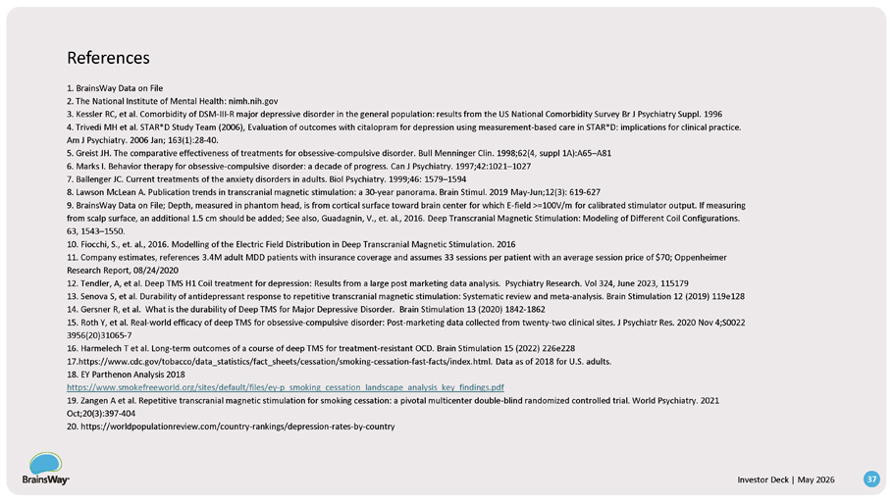
References Investor Deck | May 2026 37 1. BrainsWay Data on File 2. The National Institute of Mental Health: nimh.nih.gov 3. Kessler RC, et al. Comorbidity of DSM - III - R major depressive disorder in the general population: results from the US National Comorbidity Survey Br J Psychiatry Suppl. 1996 4. Trivedi MH et al. STAR*D Study Team (2006), Evaluation of outcomes with citalopram for depression using measurement - based care in STAR*D: implications for clinical practice. Am J Psychiatry. 2006 Jan; 163(1):28 - 40. 5. Greist JH. The comparative effectiveness of treatments for obsessive - compulsive disorder. Bull Menninger Clin. 1998;62(4, suppl 1A):A65 – A81 6. Marks I. Behavior therapy for obsessive - compulsive disorder: a decade of progress. Can J Psychiatry. 1997;42:1021 – 1027 7. Ballenger JC. Current treatments of the anxiety disorders in adults. Biol Psychiatry. 1999;46: 1579 – 1594 8. Lawson McLean A. Publication trends in transcranial magnetic stimulation: a 30 - year panorama. Brain Stimul. 2019 May - Jun;12(3): 619 - 627 9. BrainsWay Data on File; Depth, measured in phantom head, is from cortical surface toward brain center for which E - field >=100V/m for calibrated stimulator output. If measuring from scalp surface, an additional 1.5 cm should be added; See also, Guadagnin, V., et. al., 2016. Deep Transcranial Magnetic Stimulation: Modeling of Different Coil Configurations. 63, 1543 – 1550. 10. Fiocchi, S., et. al., 2016. Modelling of the Electric Field Distribution in Deep Transcranial Magnetic Stimulation. 2016 11. Company estimates, references 3.4M adult MDD patients with insurance coverage and assumes 33 sessions per patient with an average session price of $70; Oppenheimer Research Report, 08/24/2020 12. Tendler, A, et al. Deep TMS H1 Coil treatment for depression: Results from a large post marketing data analysis. Psychiatry Research. Vol 324, June 2023, 115179 13. Senova S, et al. Durability of antidepressant response to repetitive transcranial magnetic stimulation: Systematic review and meta - analysis. Brain Stimulation 12 (2019) 119e128 14. Gersner R, et al. What is the durability of Deep TMS for Major Depressive Disorder. Brain Stimulation 13 (2020) 1842 - 1862 15. Roth Y, et al. Real - world efficacy of deep TMS for obsessive - compulsive disorder: Post - marketing data collected from twenty - two clinical sites. J Psychiatr Res. 2020 Nov 4;S0022 3956(20)31065 - 7 16. Harmelech T et al. Long - term outcomes of a course of deep TMS for treatment - resistant OCD. Brain Stimulation 15 (2022) 226e228 17 .https://www.cdc.gov/tobacco/data_statistics/fact_sheets/cessation/smoking - cessation - fast - facts/index.html. Data as of 2018 for U.S. adults. 18. EY Parthenon Analysis 2018 https://www.smokefreeworld.org/sites/default/files/ey - p_smoking_cessation_landscape_analysis_key_findings.pdf 19. Zangen A et al. Repetitive transcranial magnetic stimulation for smoking cessation: a pivotal multicenter double - blind randomized controlled trial. World Psychiatry. 2021 Oct;20(3):397 - 404 20. https://worldpopulationreview.com/country - rankings/depression - rates - by - country

